Date | 30/10/2025
Team ID | NM2025TMID05937
Project name | Streamlining Ticket Assignment for Efficient Support Operations
Maximum mark | 4 marks

PROJECT DESIGN PHASE 2
TECHNOLOGY STACK (ARCHITERTURE& STACK)
Technical Architecture:
The technical architecture for the Streamlining Ticket Assignment for Efficient Support Operations project is designed as a modular, scalable, and secure system to ensure efficient automation and data-driven decision-making. It follows a three-tier architecture consisting of the Presentation Layer, Application Layer, and Data Layer, supported by intelligent automation and analytics modules.
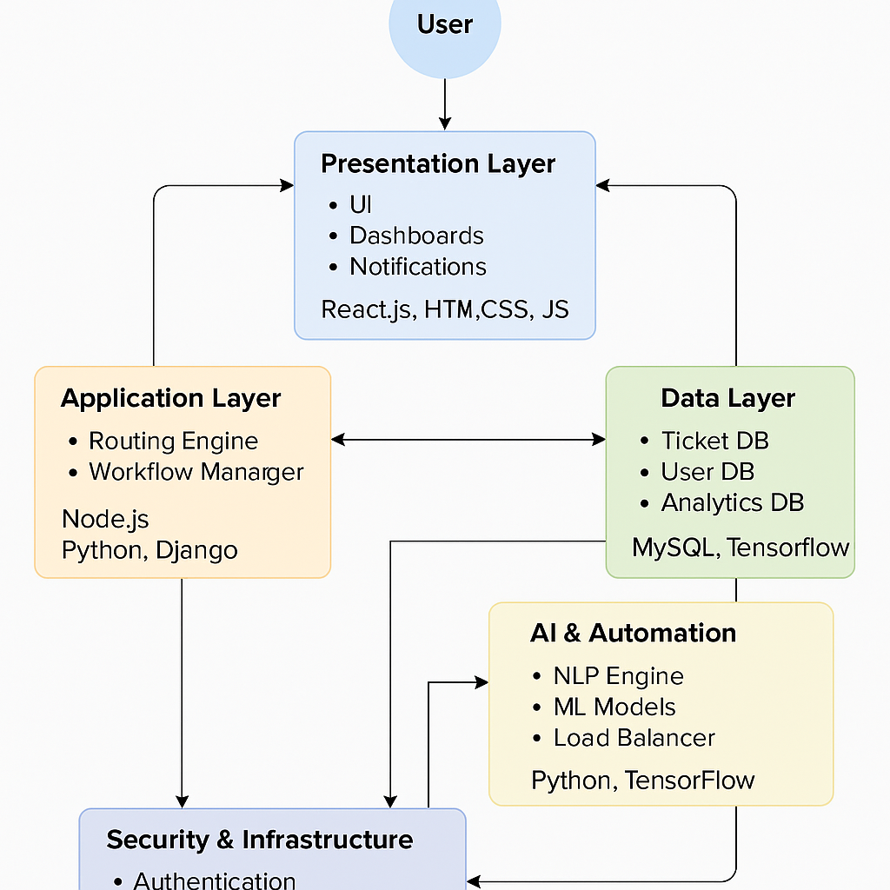

Components and Technologies:

Layer | Components | Technologies / Tools
1. Presentation Layer | - User Interface (UI)- Dashboards- Notification Center- Reporting & Analytics Views | HTML5, CSS3, JavaScript, React.js / Angular, REST APIs
2. Application Layer | - Ticket Routing Engine- Workflow Manager- Notification Service- Integration Module | Node.js, Python (Flask / Django), Express.js, Java Spring Boot
3. Data Layer | - Ticket Database- User Database- Analytics Database- Logging & Audit Database | MySQL, PostgreSQL, MongoDB, Firebase
4. AI & Automation Layer | - NLP Engine- Machine Learning Model- Load Balancer | Python, TensorFlow, Scikit-learn, spaCy, NLTK
5. Security & Infrastructure Layer | - Authentication & Authorization- Data Encryption- Cloud Deployment- Backup & Recovery | OAuth 2.0 / JWT, SSL/TLS, AWS / Azure, Docker, Kubernetes
6. Monitoring & Reporting Layer | - System Monitoring Tools- Performance Metrics Dashboard- Log Management | Grafana, Kibana, Prometheus, Power BI

